Module (JQuery Basic, Effects & Advanced) – 5

• What is jQuery?

jQuery is a lightweight, write less, JavaScript library.

The purpose of jQuery is to make it much easier to use JavaScript on your website.

jQuery also simplifies a lot of the complicated things from JavaScript, like AJAX calls and DOM manipulation.

The jQuery library contains the following features:

1.HTML/DOM manipulation

2.CSS manipulation

3. HTML event methods

4.Effects and animations

5.AJAX

6.Utilities

• How to Apply CSS Using JQuery, How to Add Class and Remove Class in Jquery , JQuery Animation?

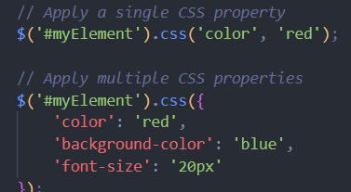

Add class:

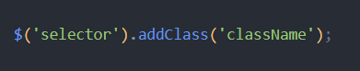

Remove class:

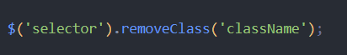

Animation:

